ST. MARY’S C.E. PRIMARY SCHOOL
What are we learning about this half term?

Teachers: Mrs Lee-Manford, Mrs Butler and Mrs Massey
Year group: 5 Term: Summer 1

SUBJECT | What we will be learning this term. | How you can support your child at home.
ENGLISH   | We will be learning more about biographical and autobiographical texts this term, and how to use cohesive devices effectively. We will then use these skills to write autobiographies using the class text, Coming to England by Floella Benjamin for inspiration.  We will continue to develop our spelling, punctuation and grammar skills. | Please read regularly with your child and identify the different language features e.g. speech, conjunctions (and, but, because, meanwhile, therefore), tense (past, present and future).  Encourage your child to use Spelling Shed and Read Theory regularly.
MATHS  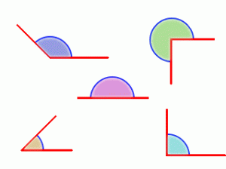 | This half term, we will be learning all about fractions, percentages, decimals and geometry.  Once we have mastered converting between fractions decimals and percentages, we will be moving on to look at 3D shapes- identifying their nets from 2D representations and using our knowledge of the properties of 2D shapes to work out missing lengths and angles.  We will also be learning about reflection and translation of shapes and angles. | Practise times tables and other mental maths skills e.g. adding two-digit numbers, doubling.  Point out measurements (e.g. converting kg to g, m to cm), fractions, decimals and percentages in everyday life e.g. in supermarkets.  Tell the time regularly and calculate how long until an event. If your child struggles to tell the time, they must work on this at home regularly – it is an important life skill.  Mathletics – www.mathletics.co.uk
SCIENCE | The children will continue to learn about animals and living things this half term in addition developing their scientific skills. The lessons will be taught by Mrs Butler. | Look for examples of living things and habitats on your travels. For example, discuss why lots of birds choose to have nests high up in trees. Look at the new flowers and plants that are growing in the local park. You could also visit: Animals - KS2 The World Around Us - BBC Bitesize
R.E.  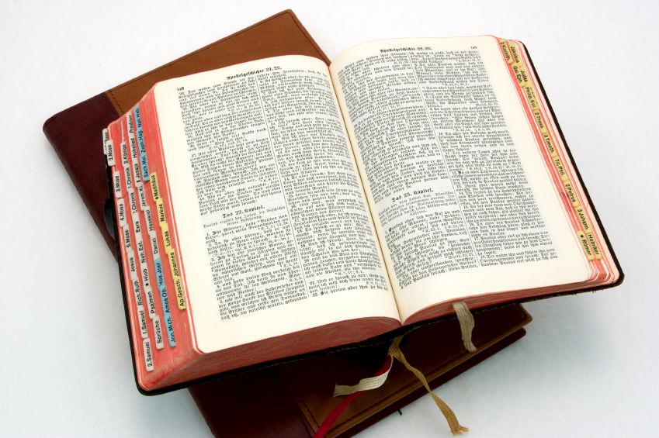 | What would Jesus do?– We will be exploring further the character of Jesus looking at him as a great teacher and how he has taught Christians about behaviour and attitudes. | Please encourage your child to read Bible stories and talk to them about what we can learn from the stories.
Computing | We are going to be learning how to create a game using a coding programme called Gorilla Code.  We will be developing our programming skills, using Purple Mash. This can also be accessed at home if your child would like to continue with their learning. | Encourage your child to log onto Purple Mash at home.
Geography   | In our geography lessons this term, we are going to be learning about Canada.  We will explore maps to learn about the country, in addition to learning about the human and physical characteristics. | Encourage your child to research at home, read newspaper reports about natural disasters that have happened in North America and use maps to locate the volcanoes and earthquakes they have learned about.
Spanish | This term we will be learning how to say the names of different countries in Spanish. We will also be learning to talk about the weather. We will continue to practise adjectives, numbers and colours throughout the term. | Encourage your child to use the words he/she has learned.
Music   | Looping and remixing: Dance music.  In the unit, the children will learn to:  - talk about electric dance music and how it is made  - explain the terms looping and mixing  - create a piece of music inspired by EDM  - Know what a repeating section is | Listen to music at home, talking about likes and dislikes.
P.S.H.E | Relationships – This term we will be discussing different types of relationships with a focus on friendship. We will talk about the qualities of a good friend and resolving conflict in a sensible way. We will also be exploring our relationship with technology and the importance of healthy screen time habits. | Talk to your child about how they can be a kind friend.
Art   | We are going to be learning about the art form of printing this term. We will look at different types of prints and compare printing artist William Morris to other types of artists before creating our own North America themed prints. | Research artists at home or visit an art gallery and discuss techniques used.
P.E.  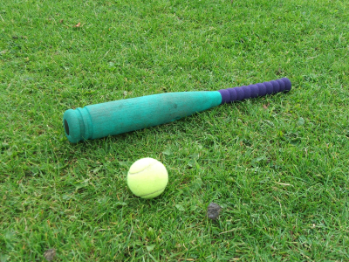 | Our new PE topics for this half term are: handball and invasion games. We will continue to develop our teamwork skills and learn about a healthy lifestyle. Our PE lessons for this term are on Thursdays. Please ensure that your child wears their PE kit to school on these days. We will also be benefitting from weekly bootcamp sessions this term on Wednesdays. | Talk to your child about how the importance of exercise and keeping healthy.

Additional information:
- Please read with your child every day (the reading book provided by school will support you in this). Please ensure that your child’s reading book and reading journal are signed and brought in every day and that the reading journal is kept up to date.
- In addition to reading daily, children are expected to complete at least 3 Read Theory tasks, per week.
- Please encourage your child to practise their spellings regularly, on Spelling Shed and complete Mathletics activities.
- The children will continue to work on the core progression skills in all areas of the curriculum.

