ST. MARY’S C.E. PRIMARY SCHOOL
What are we learning about this half term?
Teacher: Mrs Lee-Manford, Mrs Butler, Mr D
TAs: Mrs Massey and Mrs Thirsk Year group: 5 Term: Autumn 2024– 2nd half
SUBJECT | What we will be learning this term. | How you can support your child at home.
ENGLISH  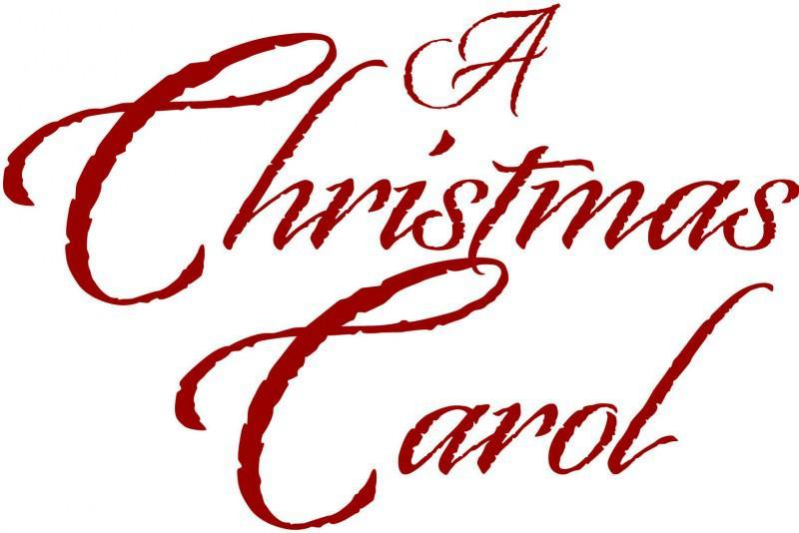 | This half term we will be using the texts, Beowulf and A Christmas Carol as a stimulus for writing.  Throughout the half term, we will be developing our use of grammar, punctuation and spellings; focusing on homophones, use of direct and reported speech, apostrophes and relative clauses. | Read regularly with your child emphasising expression and use of punctuation.  Discuss reading book s e.g. Story – How does it begin? How are characters represented /described? Predictions of what might happen next.  Help with reading journal and spellings.  Help with homework.
MATHS   | This half term, we will be building on the children’s previous knowledge of number and number operations including multiplication and division.  We will be learning more about multiples and factors and how we can use these facts to help us to solve word problems. In addition to this, we will also be fractions, beginning with equivalent fractions before moving on to convert improper fractions to mixed numbers and vice versa. We will also be exploring perimeter and area including looking at real life mathematical problems where knowledge of area and perimeter is needed. | Practise times tables and other mental maths skills eg. adding two-digit numbers, doubling.  Point out measurements (e.g. converting kg to g, m to cm), fractions, decimals and percentages in everyday life e.g. in supermarkets.  Help with homework.  Tell the time regularly and calculate how long until an event. If your child struggles to tell the time, they must work on this at home regularly – it is an important life skill.  Mathletics – www.mathletics.co.uk
SCIENCE   | What are materials and how can we change them?  (Properties and changes of materials)  The children will learn to:  - compare and group together everyday materials on the basis of their properties, including their hardness, solubility, transparency, conductivity  - Separate materials using filtering, sieving and evaporating  - give reasons, based on evidence from comparative and fair tests, for the particular uses of everyday materials, including metals, wood and plastic  - demonstrate that dissolving, mixing and changes of state are reversible changes  These lessons will be taught by Mrs Butler. | Identify forces around the home and discuss the importance of them.  Use can also use the BBC Forces activities on the computer at home.  http://www.bbc.co.uk/bitesize/ks2/science/physical_processes/forces/play/
R.E.  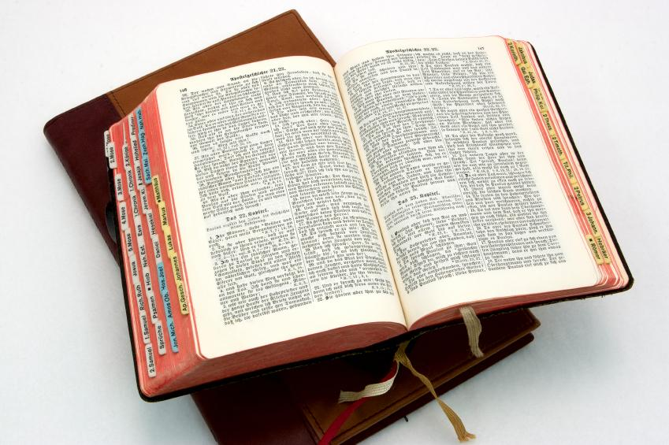 | Why do Christians believe that Jesus was the Messiah?  We will start the unit by talking about the meaning of the word ‘Messiah’ before looking at Emma Yarlett’s ‘Big Frieze’ which tells the story of the Bible in pictorial form. We will then create our own ‘big story’ pieces of artwork. We will move on to looking at the qualities of a Messiah and then look for clues in the Bible which give reasons as to why Christians believe Jesus was the Messiah. We will also look discuss what Christians mean by the true meaning on Christmas and link it back to our key question. | Read stories in the Bible that feature the Prophets Amos, Jeremiah and Isaiah.  As Christmas approaches, discuss joy, peace, birth, visitors giving celebrations.  http://www.chiddingstone.kent.sch.uk/homework/religion/christian.htm
Computing   | Concept mapping:  Our main focus will be learning how to create concept maps on the iPads and Chromebooks. We will use Purple Mash to develop our skills.  These lessons will be taught by Mrs Butler. | Talk about concept mapping at home.  To use the internet with your child to find relevant information.  Set your child a challenge to find out the answer to a question.  Discuss internet safety with your child and identify clear rules for use at home.  http://www.kidsmart.org.uk/
History | Who were the Anglo-Saxons and where did they come from?  We will be learning about who the Anglo-Saxons were and where they came from and looking at important events from this period of time. We will learn more about King Alfred and debate whether we think he is a good king and worthy of the title of Kind Alfred the Great. We will examine different sources and look at artefacts to help us to learn more about the Anglo-Saxons. | Encourage your child to carry out their own research at home, using the Internet and books.  Talk to them about their learning.
Music | The Blues  The children will be learning all about Blues music, including its history. They will listen to different pieces before appraising them. They will also be learning and performing some songs. In addition to this, the children will also be learning some Christmas songs, in the lead up to the festive period. | Please encourage your child to listen to a range of music at home. Discuss with them what you like/dislike about the pieces.  Introduce them to music you have enjoyed listening to over the years.
Design and Technology | Electrical systems  In this unit, the children will look at a range of electrical systems before developing an understanding of what an electrical system is. They will learn about how electrical systems work before designing and creating their own light up Christmas card. | Look at different ways electrical systems are used at home and when you are out and about.
Spanish | Time in the city and Christmas shopping (roleplay)  The children will learn how to talk/listen/read in Spanish about: buildings and places of interest, give directions and talk about the prices of items. The lessons will be led by our foreign language assistant. | Encourage your child to use the words he/she has learnt, at home.
P.S.H.E  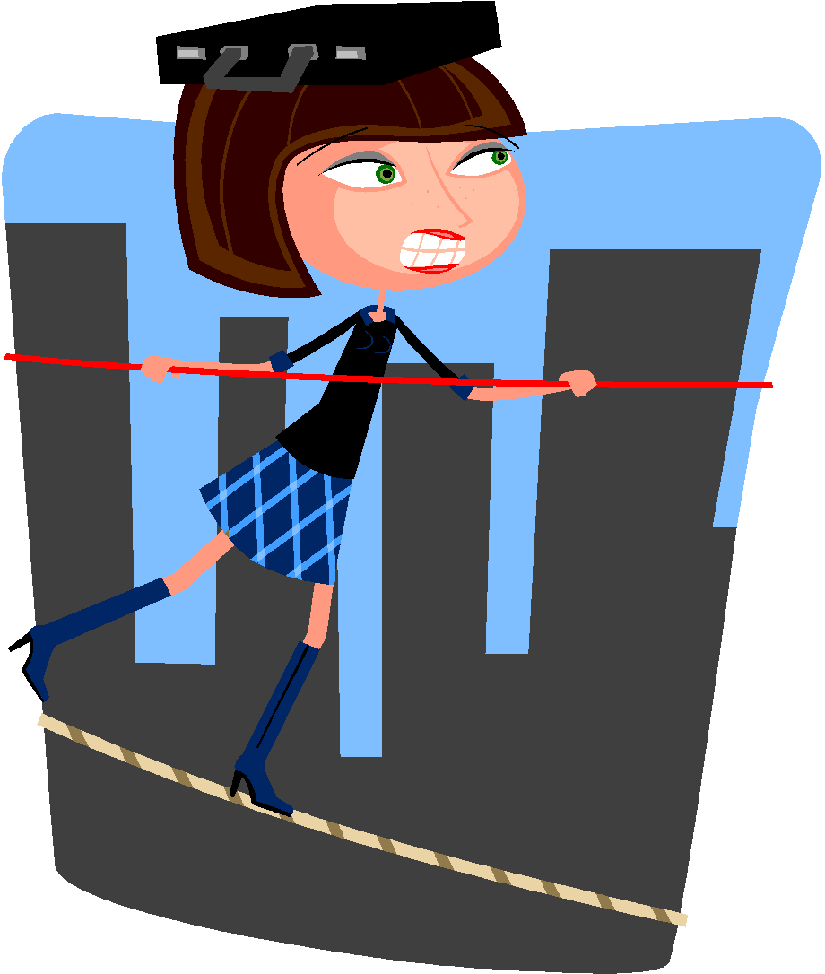 | Health and well-being  We will be talking about ways to keep healthy in addition to developing and understanding of what we can do to look after our mental health as well as physical health. | Talk about ways that you like to keep healthy. Try some activities together which promote health and well-being.  Read the paper together and discuss topical issues. Watch ‘Newsround’ or look at http://news.bbc.co.uk/cbbcnews/default.stm together.  Listen to the news and discuss topical issues.
P.E. | Yoga- the children will learn a range of Yoga techniques and stretches, which will help to develop both the body and mental health.  Health Related Fitness, and team building and problem solving. The sessions will be on a Thursday this half term, so please ensure that your child comes to school wearing their PE kit every Thursday. | Encourage an active lifestyle involving some exercise.  Encourage taking part in team games.  Talk about the benefits of keeping healthy and working as a team.
Additional information:
- Please read with your child regularly (the reading book provided by school will support you in this). Please ensure that your child’s reading book and reading journal are signed at least once a week and brought in every day.
- We will continue to work on the core skills in all subjects, as discussed at the open evening.
- We will be competing in a Lacrosse festival at FGS on 15th November (am) and will also be visited by an Anglo-Saxon in school on 9th December, who will teach us more about what it was like to live in Anglo-Saxon Britain (more information to follow).

Thank you for your co-operation and continued support,
The Year 5 team

