St Mary’s C.E. Primary School
What are we learning about this half term?

Teacher: Miss Thwaite Year group: 4 Term: Summer 1

Subject | What we will be learning this term. | How you can support your child at home.
English   | We will take the opportunity during the summer term to revise and consolidate our work on grammar and punctuation.  This half term, we will be focusing on the Literacy Shed short video, ‘The Wishgranter’. This Wishgranter is quite apathetic but when a wish for love becomes stuck in the well mechanism then the Wishgranter springs into action. Although not everything goes to plan, all is well in the end!  Our learning opportunities linking to the film will include:  - Retelling the story from various points of view.  - Writing diary entries for the various characters.  - Character descriptions.  - Writing dialogues for two of the characters.  Each day, we will be analysing a range of texts using the reading VIPERS (vocabulary, inference, prediction, explanation, retrieval and summarise) Throughout these daily sessions, the children will be given the opportunity to read aloud, discuss opinions and participate in whole class discussions relating to the given text. | Read regularly to and with your child emphasising expression and use of punctuation.  Discuss the reading book e.g. How does it begin? How are characters represented /described? Predictions of what might happen next. Question your child so that they need to ‘read between the lines.’  Access ReadTheory on a regular basis.
Maths   | Here are some of the areas of maths that we are going to cover this half term:  - Write, compare and order decimals.  - Round decimals.  - Convert pounds and pence.  - Ordering and estimating money.  - Add and subtract money.  - Give change. | Use Mathletics at home. There will be regular activities and challenges available to consolidate the learning in class.  Access Times Tables Rockstars to continue learning all times tables up to the 12x. The platform allows the children to practise all times tables as well as improving their speed and confidence.  Year 4 will be taking part in the Multiplication Times Check (MTC) in June. Children are required to know all multiplication and division facts up to 12x. Children should access Times Tables Rockstars as often as possible to support this knowledge.  https://www.gov.uk/government/publications/multiplication-tables-check-information-for-parents
Science   | Electricity - How do I construct a simple circuit? What is the difference between common conductors and insulators?  This unit is the first introduction to studying electricity in Key Stage 2. The children will learn about what electricity is and how it was discovered. They will identify which appliances use electricity in their homes and how to keep themselves safe.  Children will construct circuits, start to create pictorial circuits and conduct an investigation into how easily different types of switches can break and reconnect a circuit. | Discover more interesting facts about electricity using the following links:  https://www.bbc.co.uk/bitesize/topics/zj44jxs  https://www.theschoolrun.com/what-is-electricity
R.E.   | Unit L2.6 – For Christians, what was the impact of Pentecost?  We will focus of the following main areas:  - Make clear links between the story of Pentecost and Christian beliefs about the ‘kingdom of God’ on Earth.  - Offer informed suggestions about what the events of Pentecost in Acts 2 might mean.  - Give examples of what Pentecost means to some Christians now. | Encourage your child to have ‘quiet time’ at home where they may reflect on the events of the day.
P.S.H.E   | Relationships  Over the next half term, we will be focusing on the six following pieces of our Jigsaw journey:  - Jealousy – Recognise situations which can cause jealousy in relationships  - Love and Loss – Identify someone I love and can express why they are special to me  - Memories – I can tell you about someone I know that I no longer see  - Getting on and Falling Out – Recognise how friendships change, know how to make new friends and how to manage when I fall out with my friends.  - Girlfriends and boyfriends – Understand what having a boyfriend/girlfriend might mean and that it is a special relationship for when I am older.  - Celebrating My Relationships with People and Animals – I know how to show love and appreciation to the people and animals who are special to me. | Discuss feelings openly.  Use the Zones of Regulations to support any discussion about feelings and emotions.  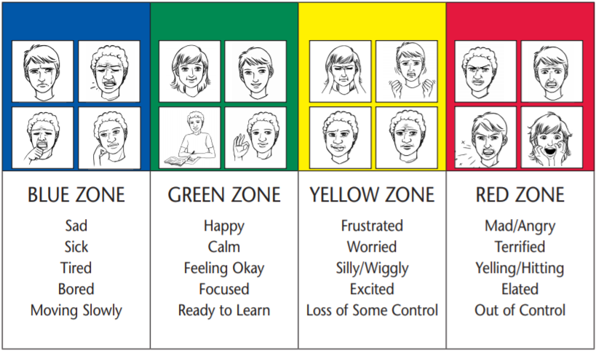
Computing   | Multimedia – Animation  Year 4 will be focusing on the following skills throughout this topic, which will lead up to the children creating their own ‘stop motion’ animation:  - Identify the meaning of animation and stop-start animation.  - Understand animation frames.  - Know what the ‘Onion Skin’ tool does in animation.  - Use backgrounds and sounds to make more complex and imaginative animation.  - Know what ‘stop motion’ animation is and how it is creating.  - Use ideas from existing ‘stop motion’ films to recreate their own animation. | Encourage your child to practise presentation skills, by giving them the opportunity to create their own project using PowerPoint or a similar software.  Also, provide support and guidance on how to navigate PowerPoint presentations. This may include; showing your child what some of the different tabs are on PowerPoint, what they do and how you can use them throughout a presentation.
Geography   | Physical geography – Volcanoes  Throughout our geography lessons we will be focussing on answering the following questions:  - What is the structure of earth?  - What are the main features of a volcano?  - What are the advantages and disadvantages of living near a volcano?  - What happens at the boundaries between the Earth’s plates?  The children will be working towards writing a report about a volcanic eruption, using all of the information gathered throughout the unit. | Follow the Oddizzi link to access all areas of our geography topic:  https://www.oddizzi.com/  Once you are logged in click on Explore the World at the top of the page.  Next, click on the Physical Features tab and lastly, click onto volcanoes.
History  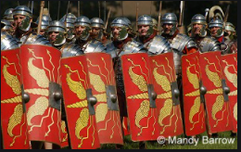 | The Romans  This half term, year 4 will be focussing on the Romans in our history lessons. Our main questions for this topic will be:  - How did the Roman Empire impact Britain today?  - What are some of the most famous Roman inventions?  We will answer these questions by researching and investigating the following focusses throughout our lessons:  - The Roman Empire and its impact on Britain.  - Julius Caesar’s attempted invasion in 55-54BC.  - The Roman Empire by AD42 and the power of its army.  - Successful invasions by Claudius and conquest.  - Hadrian’s Wall.  - British Resistance – Boudicca’s Rebellion.  - Impact of technology, culture and beliefs. | Please use the following links to extend learning about the Romans, at home:  https://www.bbc.co.uk/bitesize/topics/zwmpfg8  https://www.bbc.co.uk/bitesize/topics/zqtf34j
P.E.   | Invasion games – Basketball  Throughout our basketball sessions, the children will be developing the following skills:  - Dribble and pass the ball with a range of techniques.  - Marking skills, including man-to-man marking.  - How to get free from a defender.  - Shield the ball and the skill of pivoting.  - How to play both defensively and offensively.  - Begin to learn some of the rules of the games and how to play as part of a team.  Dance – Romans  - Learn how to listen to other people’s ideas and vocalise my thoughts.  - Show use of a Canon and changes in formation when creating and performing group section. | Please encourage your child to be as active as possible at home.  Look into clubs that your child might enjoy participating in.
Music   | Samba and Carnival – Sounds and Instruments  By the end of this unit of study, the children will be able to:  - Explain what samba music is and that it is mainly percussion instruments used in celebrations such as Carnival in Brazil.  - Clap on the off beat (the and of each beat) and be able to play a syncopated rhythm.  - Play their rhythm in time with the rest of their group (even if they are not always successfully playing in time with the rest of the class).  - Play their break in time with the rest of their group and play in the correct place in the piece.  - Play in time and with confidence; accurately playing their break.
Spanish   | Spanish  This half term in Spanish, the children will be learning about the following:  - Feeling well  - Feeling Unwell  - Jungle animals  - Fantastical animals  They will learn a range of vocabulary linked to each of these topics. The children will learn how to pronounce the vocabulary and how to structure sentences. | Encourage your child to practise basic Spanish vocabulary learnt in previous years. For example:  - Numbers  - Colours  - Day of the week  - Months of the year  - Animals
Design and Technology  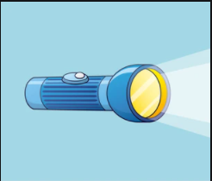 | Electrical systems – Creating torches  Throughout this topic, year 4 will be learning how to create a torch. This topic has a cross-curricular link with our science topic this half term.  Over the next 5 weeks, the children will be developing their understanding of electric systems, different types of switches and then eventually use this knowledge to create their own torch. To support this development, the children focus on the following areas:  - Identify the different features of a torch.  - Design and make different types of switches and investigate casings.  - Design a torch and its purpose and begin to identify steps in making a torch.  - Making the torch and then effectively evaluate their product against the original specifications. | Use the following links to find out more about torches:  https://www.bbc.co.uk/bitesize/clips/zb3s34j  https://www.stem.org.uk/resources/elibrary/resource/30645/questions-about-light

Additional information:

Spellings: Spellings will be set on Spelling Shed every Friday. They will also be sent home as a paper copy. Throughout the week, we will be learning spelling strategies linked to the spellings for the week. It is expected that the children will have completed a minimum of five Spelling Shed challenges each week.

Reading: Children can change their reading books and Reading for Pleasure books at any point throughout the week.
Please read on a regular basis with your child at home and make a note of this in their reading journals.

P.E. is on a Friday. Children should come to school in their P.E. kit. i.e. plain black shorts/joggers/leggings, plain white t-shirt, school jumper and trainers. No other sportswear is permitted. Children will be required to remove their own earrings. If they are unable to do this, please take them out prior to coming to school or provide tape for your child to cover their own earrings.

Kind regards

Miss Thwaite, Mrs Wali and Mrs O’Leary

