 | Autumn 1 | Autumn 2 | Spring 1 | Spring 2 | Summer 1 | Summer 2
Potential Themes/ Interests of children | Starting School  Autumn  Harvest  Family  Who am I? | People Who Help Us Christmas  Celebrations including Diwali | Winter  Arctic environments  Journeys  The world around us  Chinese New Year | Growing up - babies, generations  Health inc. oral health Spring  Easter  The Farm | Life Cycles - butterflies, beans, sunflower  Outdoors  Gardening | Summer  Hot environments  Rock pools  Mermaids  Pirates  Seaside
Possible Celebrations & Experiences | Starting School, , Autumn, Black History Month, | Diwali , Bonfire Night,  Children in Need, Remembrance Day, Advent, Christmas,  Christmas Nativity  People Who Help us visitors | Valentine's Day,  Lunar New Year / Chinese New Year, Safer Internet Day | World Book Day, Comic Relief, Mother's Day, Pancake Day,  Easter |  | Father's Day , Sports Day,  Transition
Suggested Texts – Fiction and Non-Fiction | 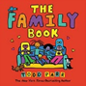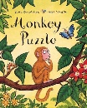 | 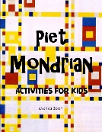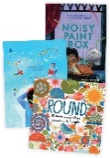 | 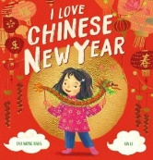  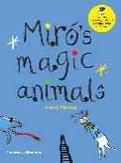 | 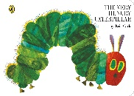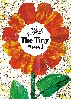  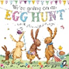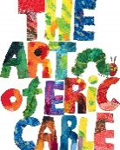 | 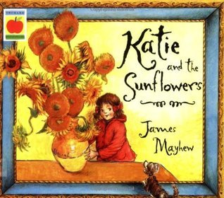 | 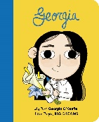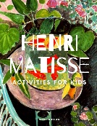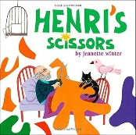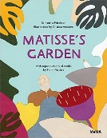
Class | Aut 1 | Aut 2 | Spr 1 | Spr 2 | Sum 1 | Sum2
R | All About Me  Using tablets to play games to support learning. | People Who Help Us  Retelling stories using images / apps.– Story Maps. | Amazing Animals  Use images, video clips, shared texts and other resources to bring the wider world into the classroom. | Come Outside  Use the BeeBots  (directions) | Ticket To Ride  Use bee-bots on simple maps.  Comparing places on Google Earth – how are they similar/different? | Fun At the Seaside  Use QR codes on iPads to read stories.
1 | Information technology  (PM – Creative Computing )  To use paint tools to draw a picture.  To create a jigsaw using a digital device and share it so that others can play.  To create a placing game in 2DIY.  To create images and use these to make a game.  Arrow keys, digital art, drag and drop, hotspot, touchscreen gestures | Information technology  (PM – Data Explorers)  To think carefully about the steps of grouping items.  To group items using a computer.  To sort different items.  To understand that data is information that can be collected and used.  To understand that data can be shown using pictures.  To collect data and create a pictogram.  Algorithm, criteria, data, group, pictogram, sort | Computer Science  (PM - Creating & Following Instructions)  To understand that an algorithm is a set of instructions.  To follow and create simple instructions on a device.  To sequence algorithms that require a correct order.  Algorithm, coding, computer bug, debugging, instructions, program | Information technology  (PM - Animated Stories)  To understand some differences between traditional books and digital books.  To draw a character for a 2Create a Story digital book.  To understand the difference between backgrounds and other objects on the screen in 2Create a Story.  To add animation to objects in 2Create a Story.  To add text to a 2Create a Story file.  To add sounds to a 2Create a Story file.  Animation, easer, background, sound effect, digital book, undo. | Computing Science  (PM – Coding)  Understand what instructions are and predict what might happen when they are followed  Know how to use code to make a computer program.  Understand what objects and actions are.  Understand what an event is.  Understand what backgrounds and objects are.  Know how to plan and make a computer program.  Action, Algorithm, Background, Code, Coding, Command, Debug, Event, Execute. | Information technology  (PM – Making Beats)  TBC
2 | Computer Science  (PM - Route Explorers)  To use the direction keys in 2Go to move the turtle along a route.  To use units of distance along with the direction keys in 2Go to move along a route.  To write instructions to complete more than one-step of a route at once.  To build up instructions for a longer route.  Algorithm, coding, computer bug, command, debugging and direction.  Information Technology  (PM - The Internet)  To understand how the internet, the World Wide Web and a browser work together.  To understand the different types of hardware used to access the internet and their functions.  To understand the difference between a website and a webpage and use a school website to find information.  To understand the difference between a browser and a search engine, and to practise searching for information safely.  Browser, smart device, home page, webpage, internet, Wi-Fi, search Engine and World Wide Web. | Information Technology  (PM - Creating Pictures)  To create a digital art piece in an Impressionist style.  To create a digital art piece in a Pointillism style.  To create a digital art piece that is in the style of Piet Mondrian's work.  To create digital art patterns in the style of the Arts and Crafts movement.  To create a portfolio of digital art.  Import, palette, De Stijl, impressionism, digital portfolio, image picker, pointillism. | Information Technology  (PM – Spreadsheets)  To understand what a spreadsheet is and how to navigate one using 2Calculate.  To edit and improve a spreadsheet so that information is organised clearly and displayed correctly.  To explore how spreadsheets can complete calculations automatically.  To explore the range of tools available in 2Calculate and understand how they can change the way data is used.  To create and interpret block diagrams from data.  To use our learning about spreadsheets to help us complete a project.​  Axis/axes, cell, column, row, spreadsheet and value. | Information Technology  (PM – Questioning)  To understand how data can be used to help answer a question  To ask an appropriate question, gather data using a tally chart and present it using digital tools.  To begin to explore how yes or no questions can be used to sort data.  To understand how branching databases work and practise navigating them to find answers.  Vocabulary: branching database, pictogram, close questions, sorting, data, tally chart and open question.  Computer Science  (PM – Coding)  TBC | Information Technology  (PM – Presenting Ideas)  TBC | Information Technology  (PM – Making Music)  TBC
3 | Digital Literacy  (PM – Email)  To understand how people communicate with each other.  To understand and respond to an email.  To compose and send an email.  To send an email attachment.  To learn how to use email safely.  To explore simulated email scenarios.  Address book, email, personal information, attachment, recipient, compose, password. | Computing science  (PM – Route Planners)  To create simple commands in 2Go to move the turtle along a route.  To create commands in 2Go in which the turtle turns using rotation.  To plan algorithms and write 2Go code that uses angles of turn.  To use 90° and 45° angles in 2Go.  To use the repeat algorithm and coding in 2Go.  Algorithm, angle, degrees, repeat, route, rotation, command. | Information Technology  (PM – Branching Databases)  To understand the concept of using 'Yes' or 'No' questions to sort objects.  To understand and use a branching database effectively.  To plan and create a branching database.  To test and debug branching databases to correct errors.  Binary choice, data, debug, database. | Information Technology  (PM – Spreadsheets)  TBC | Computer Science  (PM – Coding)  TBC | Information Technology  (PM – Presentation)  TBC  Information Technology  Touch Typing  To learn correct finger positioning on the keyboard and understand when to use the left or right hand.  To learn how to type numbers accurately and to use the shift key for capital letters.  To practise typing punctuation marks and symbols and build accuracy with simple words.  To practise typing sentences using capital letters, spaces, and full stops.  Bottom keys, number row, space bar, home keys, posture, top keys, keyboard, shift key, typing.
4 | Information Technology  (PM -Unpacking Hardware & Software)  To understand what technology is, where we see it in everyday life, and how it helps us at school, home and beyond.  To identify and describe different pieces of computer hardware and understand their functions.  To understand what software is and how we use it to complete tasks.  To explore how hardware and software interact to complete everyday tasks.  Application (app), input, software, component, output, storage, technology. Hardware. | Information Technology  (PM – Amination)  To understand what animation is.  To understand the term onion skinning and be able to use this technique for 2D computer animations.  To know how to enhance simple animations using animation software.  To plan an animation.  To create a narrative through animation.  To evaluate animations.  Animation, copy frame, sharing controls, frame, sound, onion skinning, storyboard. | Computer Science  (PM – Logo)  To know key commands and input simple instructions.  To use a variety of commands to create shapes using multi-line mode.  To use the Repeat command.  To change the line thickness and colour.  To use procedures to write instructions.​  Logo, pen down, repeat, procedure, logo commands.  Information Technology  (PM - Sound stories)  To understand what makes audiobooks effective and identify the key features that make them engaging.  To plan and write a script for an engaging audiobook.  To record clear narration and add sound effects to an audiobook.  To edit, improve and finalise an audiobook using recording and sound design tools.  Audiobook, playback, background music, recording, timeline, sound effects, track, editor. | Digital Literacy  (PM - Effecting searching)  To understand what a search engine is, how it works and how to use simple keywords to find information online.  To understand how search engines collect, sort and rank results, and why some results appear first.  To learn advanced ways to improve searches so we can find the most accurate and useful results quickly.  To develop strategies to judge whether information online is true and if sources can be trusted.  Crawl, internet, search bar, exact match, search engine, fliter.  Computer Science  (PM – Coding)  TBC | Information Technology  (PM - Composing beats)  To identify and discuss the main elements of music.  To understand and experiment with rhythm and tempo.  To create a melodic phrase using varied notes and pitch.  To compose a piece of electronic music.  Dynamics, pulse, synths, tempo, texture, rhythm, pulse, melody. | Computer Science  (PM - Micro:bits)  To code a micro:bit to make it work as a step counter.  To code a micro:bit to make a light switch that switches on or off when the light level changes.  To code a micro:bit to make a rock, paper and scissors game.  To code micro:bits to make simulated dice.  Accelerometer, sensor, data, simulation, gestures, light sensors, variable, logic.
5 | Information Technology  (PM –Quizzing)  To explore different types of quizzes and identify their features, strengths and weaknesses.  To explore the features of 2Quiz and experiment with creating quiz questions.  To explore additional features of quizzes, such as title screens and content pages.  To apply knowledge of 2Quiz to design an educational quiz based on a chosen topic.  To be able to refine, test and share completed quizzes.  Quiz, interactive, features, simple, advanced, debug. | Databases  (PM – Databases)  To understand what a database is.  To design and create a database.  To build queries to find information.  To solve problems using a database.  Condition, filter, query, data, record, databases, validation, operator. | Computer Science  (PM - Game Creator)  To evaluate the features of a successful video game.  To plan a game in 2DIY3D.  To design and use game sprites.  To add features to a game world and check playability.  To evaluate games created by others. ​  Game environment, playability, game feedback, sprite, animation. | Spreadsheets  (PM – Spreadsheet)  TBC | Computer Science  (PM – Coding)  TBC | Information Technology  (PM - Word processing)  TBC  Information Technology  (PM - Concept maps)  TBC
6 | Computer science  (PM - Networks)  To understand what a computer network is and identify examples of networks at home, school and in the wider world.  To understand the difference between the internet and the World Wide Web and explore the services they provide.  To explore how the internet can be used for communication and collaboration, and how to do this safely and respectfully.  To explore who is in charge of the internet and how rules and website blocking can affect people, society and online platforms.  Network, email. Web browser, router, website, Wi-Fi, Local Area Netwrok, Wide Area Network, World Wide Web | Information Technology  (PM – Graphing)  To create comparative bar charts using graphing software.  To create pie charts using graphing software.  To create line graphs using graphing software.  To present data in graphs to support an argument.  Chart, data, dual bar chart, comparative bara chart, dataset, line graph, pie chart. | Information Technology  (PM – Blogging)  To understand blogs and their features.  To plan the theme, content and structure for a blog post.  To write and style a blog post.  To review and comment on blog posts with an understanding of online safety.  Approval, Hyperlink, Publish, Moderation, Revise, Blog, commenting, vlog, draft, netiquette. | Computer Science  (PM – Coding)  TBC  Computer Science  (PM – Introduction to Python)  TBC | Information Technology  (PM – Spreadsheets)  TBC | Information Technology  (PM – 3D Modelling)  TBC

