ST MARY’S C E PRIMARY SCHOOL
What are we learning about this half term?

Teacher: Miss Thwaite Year Group Year 2 Term: Autumn 1
SUBJECT | What we will be learning this half term. | How you can support your child at home.
ENGLISH   | This half term we will be focussing on the basic skills of writing. We will be writing sentences with capital letters, full stops and finger spaces. We will practise our sounding out of new words using our phonics and making sure our letters are the correct height in our handwriting. We will also practise proofreading our work for errors and then editing it to improve our language. To start with, we will base our writing around the text of ‘The Fantastic Flying Books of Mr Morris Lessmore’ by William Joyce. | Read daily with your child, asking questions and talking about what different words mean and why particular punctuation has been used.  Practise spellings with your child, particularly emphasising the correct spelling of common exception words.
MATHS   | This half term we will focus on our understanding of number and place value. We will learn to read and write numbers to 100 and we will learn how to make these using different resources. We will also practise our addition and subtracting skills, learning which methods work best for us. | Practise times tables using Times Table Rockstars.  Use Mathletics to practise different skills.  Practise counting in 2s, 5s and 10s.
R.E.  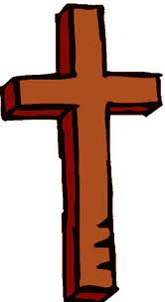 | What do Christians believe God is like?  We will learn that many Christians believe in God and that stories from the Bible help them to understand what God is like. We will particularly look at the parables of the lost son, the lost sheep and the lost coin. | Talk with your child about a time when you have forgiven someone.
Computing   | Multimedia – making pictures  We will look at different styles of art work and use 2 Paint a Picture on Purple mash to help us create our own artwork in these different styles. | Log into Purple Mash at home and use 2 Paint a Picture to create work in the style of different artists.
History  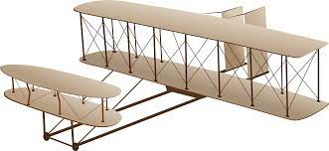 | How did we learn to fly?  This half term we will learn about the Wright Brothers and how they invented the first engine powered glider. We will investigate different sources which will teach us about these events and discuss the impact they had on the history of aviation. | Watch the videos on the Year Two page of our school website.
Science   | What materials can we make planes from?  This half we will be focussing on the following:  Identify and compare the suitability of a variety of everyday materials, including wood, metal, plastic, glass, brick, rock, paper and cardboard for particular uses.  Describe how the shapes of solid objects made from some materials can be changed by squashing, bending, twisting and stretching. | Discuss what materials everyday items are made from and why they might be made using this.
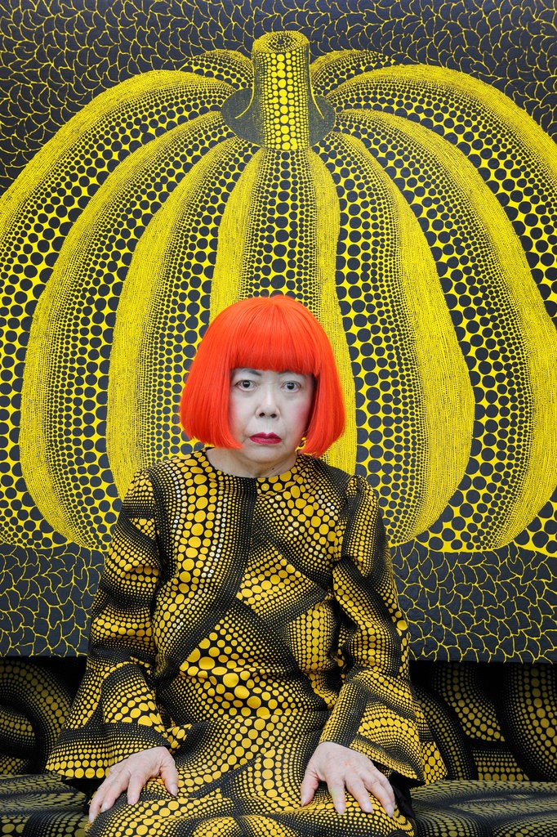  Art | We will be learning about drawing, pattern and line. As part of this we will learn more about Yayoi Kusama, a Japanese artist who often uses these in her work.  We will focus specifically on learning:  - To explain what crosshatching is.  - To describe how different grades of pencil can create different effects.  - To describe how to create a repeating pattern. | Create your own masterpieces, using different patterns and choosing different lines to create different effects.
P.E.   | In our tri golf lessons, we will practise aiming the ball with accuracy. We will learn how to use the putter and chipper to achieve different results. Once we are more confident with our skills we will set up the playground for our own games of mini-golf.  In our invasion games lessons, we will learn how to intercept a pass and dodge around our opponents. | Practise your golf swing, aiming the ball at different targets.  Discuss tactics when playing games together.
MUSIC  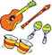 | On this island  Taking inspiration from the British Isles, we will explore how to create sounds to represent three contrasting landscapes: seaside, countryside and city. We will develop an idea of what each of these places would sound like and use this to create our own soundscapes. | Sing some of the folk songs we have been learning to your adults at home. Do you know any other sea shanties?
SPANISH   | This half term we will start by learning different greetings and farewells in Spanish. | Reinforce Spanish language at home by counting, practising the colours or animals. Practise greetings and farewells.
PSHE  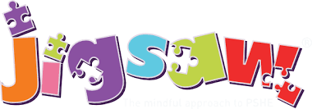 | Being me in my world  We will discuss our hopes and fears for the new school year. We will discuss how we can make our school a better place and how we can respect everyone’s right to learn. We will work cooperatively to develop our own learning charter. | Discuss how you felt when you have had a new beginning and who your child can talk to if they feel worried. Discuss how we can help keep school a safe and fair place.

Additional Information:

- Reading
Read with your child daily. The reading books provided by school will support you in this. Please fill in the reading journal each time you hear your child read (whether it’s their school reading book or another book from home) and ensure that your child’s reading book and reading journal are brought in every Monday.

- Homework
- Spellings: Children will given a spelling book. They will be given 8 words to practise three times throughout the week. There are activity ideas in the front of the spelling book to help the children practise.
Maths: Children will receive a maths folder. Each week, a new worksheet will be added to the folder for the children to complete at home. The folders should be returned to school each Friday, ready for a new sheet.
Times Table Rockstars: Children will be given a Times Table Rockstars login. They should focus on practising the 2, 3, 5, and 10 times tables.

- P.E.
P.E. is on Friday afternoon. Please make sure that your child comes to school in their outdoor P.E. kit on this day i.e. black shorts / joggers, plain white t-shirt, school jumper and trainers. No other sportswear is permitted. Children will be required to remove their own earrings. If they are unable to do this, please take them out prior to coming to school or provide tape for your child to cover their own earrings.

- Volunteers
We would welcome help from parents/ carers/ grandparents to hear readers in the class. Please see Miss Thwaite if you can help.

Kind regards,

Miss Thwaite

Characteristics of effective learning – Year 2

Showing curiosity about objects, events and people e.g. Asking questions about their topics such as the history of flight.  Using senses to explore the world around them e.g. Noticing how living things grow and change.  Showing particular interests e.g. having favourite subjects and topics across the year. | Representing their experiences in play e.g. Acting out experiences during playtimes.  Taking on a role in their play e.g. Becoming another person or character during playtime or drama activities.  Acting out experiences with other people e.g. playing these ‘roleplay’ games with a friend or a group of friends. | Seeking challenge e.g. completing the next challenge of work during the maths lesson or asking the teacher for a challenging question.  Showing a “can do” attitude e.g. Keeping on trying to work an answer out even after getting it wrong.  Taking a risk, engaging in new experiences, and learning by trial and error e.g. Answering a maths question using a different method. | Showing a deep drive to know more about people and their world e.g. showing a passion for geography or answering questions when learning about the continents.  Maintaining focus on their activity for a period of time e.g. completing their work during lessons to the best of their ability.  Showing high levels of involvement, energy, fascination e.g. showing enthusiasm for the topics they are learning.  Not easily distracted e.g. focusing on their work with classroom distractions happening.  Paying attention to details e.g. Spotting the teacher’s mistakes in their writing during the input. | Persisting with an activity or toward their goal when challenges occur e.g. developing a new strategy when completing calculations.  Showing a belief that more effort or a different approach will pay off, and that their skills can grow and develop (growth mind-set) e.g. completing extra work at home in relation to what we have been learning in class.  Bouncing back after difficulties e.g. fixing their pink in lessons and learning from their mistakes. | Showing satisfaction in meeting their own goals (I can!) e.g. being happy when they achieve their aims.  Being proud of how they accomplished something – not just the end result e.g. children being happy with a process and not just the end result, for example independently fixing their pink  Enjoying meeting challenges for their own sake rather than external rewards or praise (intrinsic motivation) e.g. Children continuing to reach a goal they have set themselves and not giving up. | Thinking of ideas that are new and meaningful to the child e.g. using descriptive words that weren’t suggested or modelled by the class teacher in their writing.  Playing with possibilities (what if? what else?) e.g. Asking in-depth questions such as “What else can I do to improve my writing?”  Visualising and imagining options e.g. thinking of different mathematical methods to answer a question.  Finding new ways to do things e.g. Finding an easier method to complete calculations. | Making links and noticing patterns in their experience e.g. linking similar texts that have been read in class.  Making predictions e.g. what might happen next in a text or investigation.  Testing their ideas e.g. testing out predictions in a science experiment  Developing ideas of grouping, sequences, cause and effect e.g. children offering ideas as to why things have happened. | Planning, making decisions about how to approach a task, solve a problem and reach a goal e.g. getting equipment to help them solve a maths problem.  Checking how well their activities are going e.g. checking their spelling during dictated sentence activities.  Flexibly changing strategy as needed e.g. getting different mathematical equipment.  Reviewing how well the approach worked e.g. during a discussion with their class teacher they can verbally evaluate their DT project.

