
ST. MARY’S C.E. PRIMARY SCHOOL
What are we learning about this half term?

Teacher: Mrs Lee-Manford and Mrs Butler Year group: 3 Term: Spring 1

Subject | What we will be learning this term. | How you can support your child at home.
English   | Firework Maker’s Daughter by Philip Pullman  We will be using this text to our term as it is a great story that we can use to inspire us in our English work. Using this book, we will write descriptive pieces of writing, writing from another point of view and we will write some diary entries too.  Reading comprehension  We will be focusing a lot on comprehension this half term, looking at context and understanding how questions can be literal or inferential.  Spellings  These will continue as normal on a weekly basis, on Spelling Shed.  Grammar and punctuation  As well as revisiting and recapping punctuation and grammar work from the Autumn term, we will be working on using ‘a’ and ‘an’ correctly in our writing, according to whether the next word begins with a consonant or a vowel.  Handwriting  We will continue to focus on the size and formation of our handwriting and joining up letters. | Discuss the Firework Maker’s Daughter with your child. There are many resources online.  Are you enjoying the book? Why not?  Why do you think she chooses to be a Firework Maker?  Is she brave?  What does a diary entry look like?  Do you write a diary at home?  Please keep on supporting your children with their reading, spelling and handwriting!
Maths | This half term we will be focusing on the following areas of maths.  - Recalling and using multiplication and division facts for the 3, 4 and 8 multiplication tables.  - Column addition  - Column subtraction  - Additive relationships | Use Mathletics regularly. www.mathletics.co.uk  Times Table Rockstars.  Continue to practise times tables with the children. Challenge them by asking them to solve multiplication and division problems.
Science  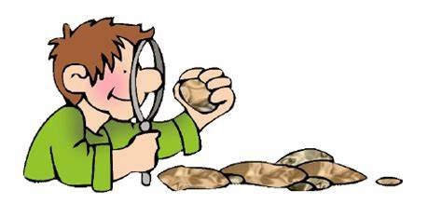 | Our new topic for this half term is  Forces & Magnets  How do forces and magnets make things move?  Children know how things move on different surfaces.  Children know that magnetic forces can act at a distance.  Children know that magnets attract and repel each other and attract some materials but not others.  Children know some magnetic materials and some materials which are not magnetic.  Children know magnets have two poles. | Please follow the links on our class webpage to some great activities all about ‘Light and Shadows’.  Discuss with your child about how light travels form the sun to Earth. Discuss common misconceptions,  i.e. that the moon ‘shines’ or that the sun ‘moves’.
Geography   | We will be working on a geography-based topic this half term. The children will look at the geography of the UK and some parts of Europe- from the physical features of mountains, rivers and seas to the man-made regions and counties. We will find out how the UK has changed over time, with a specific focus on our local area and land use. We will be developing our map skills, which will include how to use the symbols and a key on a map. We will also focus on how to use an 8-point compass to build our knowledge of the UK and the wider world. | Discuss direction when you are out and about  E.g.  Manchester is in the North West of the UK  Urmston lies south of the city centre  Discuss different maps of the UK and location of cities.  Look at the land use in our local area and discuss how and why this has changed over time.
Music  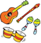 | In music this half term, we will be learning about pentatonic melodies and composition linked to Chinese New Year).  The children will learn to dance in response to musical elements- crescendo, tempo and duration.  They will also learn how to  create and perform a piece of music called ‘Enter the Dragon’.  In addition to writing and perform a ballad. | Ask the children to share with you what they have been learning. Listen to music at home and discuss what instruments you can hear..
Art  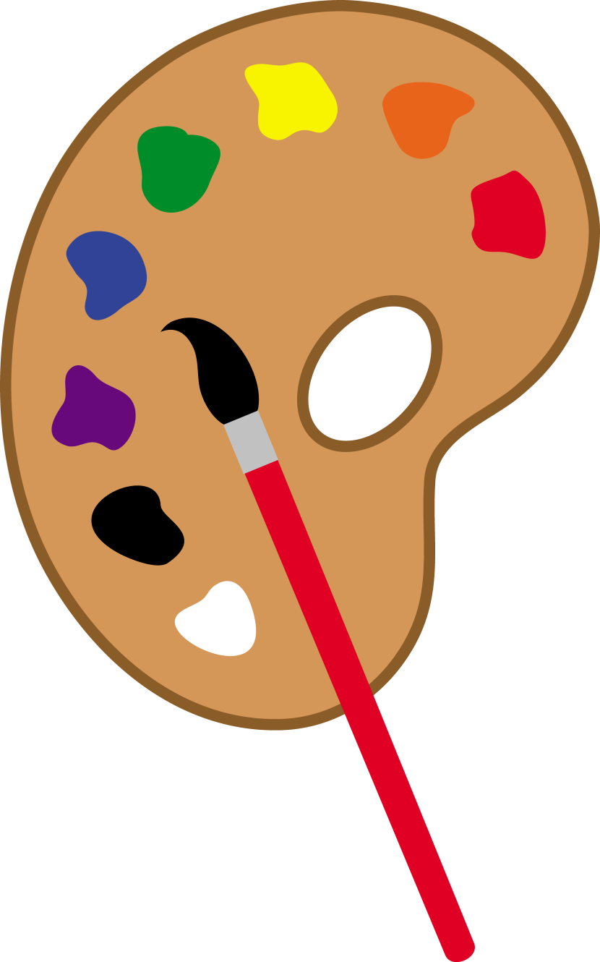 | In art, we will be focusing on our drawing skills. The children will be using line to create patterns and using tone and shade effectively. We will be drawing landscapes of the local area, using perspective. Throughout the unit of work, we will look closely at the work of artists such as Joan Miro and Ken Done. | Ask the children to show you some of the drawing techniques they have been working on.  Click on the links to discover more about some of the artists we have been learning about in class.  https://artsycraftsymom.com/10-joan-miro-projects-for-kids/  https://kendone.com.au/about-resources.php
P.E.   | We will begin with athletics in our weekly P.E. lessons with our sports coach. The children will be working on running, jumping and throwing techniques.  The children will also have some yoga lessons, working on meditation and control. | Ask the children to show you what they have been learning in their P.E. sessions.
R.E.  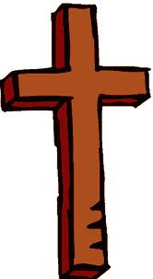 | This half term we will be learning how festivals and worship matter to Muslims.  The children will be identifying some beliefs about God in Islam and they will make links between the way in which Muslims worship and their beliefs. We will begin to understand why the mosque is important within Muslim communities and we will study some Muslim festivals. | Talk to your children about the Muslim faith. Ask them to share their learning with you.
PSHE   | Our Jigsaw unit of work this half term is all about dreams and goals. We will discuss how we can stay motivated when facing challenges and the importance of having a positive attitude. We will focus on working hard to achieve goals as well as helping others to achieve their own personal goals. | Talk to your children about what we learn and discuss in PSHE. Promote positive thinking and showing resilience when times are challenging.
Spanish | In Spanish, the children will continue to recap prior learning alongside learning new Spanish vocabulary with our Spanish teaching assistant. | Ask the children to share their learning with you.  http://www.bbc.co.uk/education/subjects/zxsvr82  http://www.bbc.co.uk/schools/primarylanguages/spanish/

Additional information:
- Reading – It is important that you read with your child or discuss their reading book every day. Please ensure that your child’s reading journal is signed and brought in to school every day and the reading journal is kept up to date.
- Homework- As well as daily reading, the children will need to continue to access Mathletics, Read Theory and Times Table Rockstars, to practise key skills.
- Spelling Shed- New spellings will be added to Spelling Shed each week for the children to practise. They should be accessing this resource as often as possible as part of their weekly homework. We will still be doing daily spelling work in class.
- PE is on a Friday this half term. The children will need to come to school in their P.E. kits on their P.E. day. Earrings must not be worn. No logos or football kits please.

