ST MARY’S C E PRIMARY SCHOOL
What are we learning about this half term?

Teacher: Mr Collingwood Year Group: Year 1 Term: Spring 1 2026

SUBJECT | What we will be learning this half term. | How you can support your child at home.
ENGLISH   | We will be continuing to focus on phonics (daily), tricky words, handwriting and writing sentences independently. We follow a text-based curriculum which means that we use a text to inspire our learning. The texts that we will be using this half-term are:  Meerkat Mail by Emily Gravett  All about Meerkats (non-fiction)  We will then be writing our own meerkat factfile. | It is essential that your child reads with you every day in order for them to progress. Ask your child questions about what they have read.  Regular phonics practise using the texts and sheets we send home each week. Promote independence when writing, encouraging the children to check their work carefully.
MATHS   | This half-term we will finish off our focus on the numbers 0-5 where we will develop factual and conceptual fluency in these numbers.  We will then move on to recognise, compose, decompose and manipulate 2D and 3D shapes. | Counting games.  Reading and writing numbers.  Number formation.  Number bond practise.  Times table practise (2, 5 and 10)  Useful apps:  Mathletics.  Log in details are stuck in the inside cover of your child’s reading journals.
R.E.   | Who is Jewish and how do they live?  We will be looking at Judaism this half term, including what Jews believe and how the celebrate certain festivals. | Think about your family traditions and why these are important to you.
Computing   | In computing, we will understand simple algorithms and algorithmic thinking. This is facilitated though unplugged activities before moving to sequencing activities on digital devices. This is a foundational unit, introducing the basis of logical thinking in preparation for coding. | Support your child with their learning by using free children’s programming software such as Scratch.  Useful apps:  Sprite box  Scratch Junior
Topic: Geography  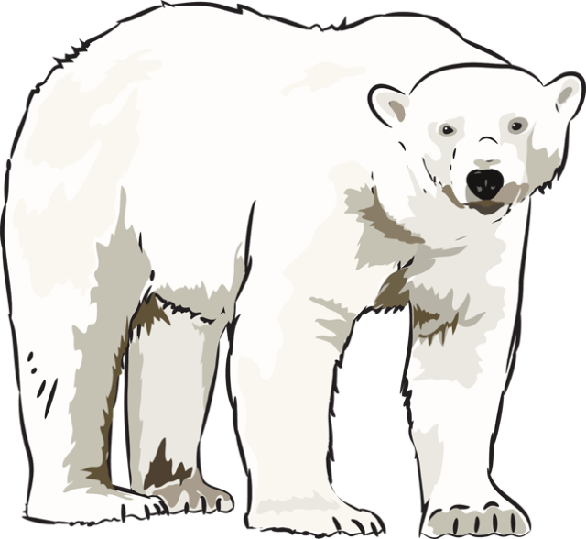  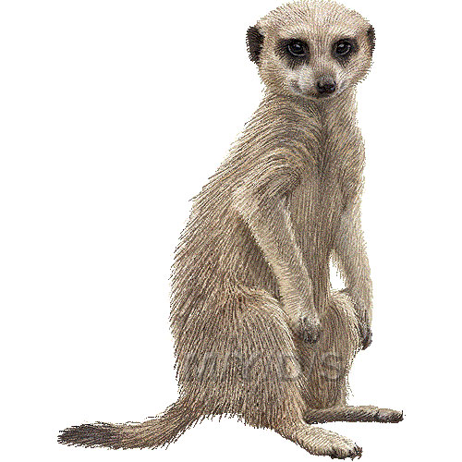 | Frozen Planet/Can a meercat live in the North Pole?  Our topic starts with a focus on the colder regions of the planet and the animals that live in the Arctic and Antarctic. We will compare these places to our own area and climate. We will also be exploring Climate Change and how it is important to look after our planet for future generations. This also feeds into our work as a UNICEF Rights Respecting School. | Talk to your children about places they (or you) may have visited on holiday. Discuss the climate in those places and how you may have prepared for such temperatures.  Look at images of hot and cold places and talk about the animals we might find in these places.
Science   | We will also be linking to our topic work and looking at different animals and whether they are carnivores, herbivores or omnivores. We will be classifying animals into mammals, reptiles, fish and birds. | Discuss different animals and their diets.
P.E.   | In P.E. the children will be working on their movement skills. We will be tying in our topic work by using animal inspiration to complete dance routines. We will also be learning some gymnastic skills focusing on balance and movement. | Ask the children to show you a range of different movements and shapes we have learnt in our P.E. lessons.
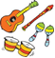  MUSIC | We will make links between music, sounds and environments and use percussion, vocal and body sounds to represent calm or stormy seas. | Ask the children to share with you some of the songs they have learnt.
SPANISH   | In Spanish we will explore New Year traditions in Spain and we will begin to learn how to say different animals in Spanish. | Ask your child to teach you some Spanish words and songs that we have been listening to.

Additional Information:
- Read with your child daily. The reading book provided by school will support you in this. We will also be sending home texts that reinforce the phonics sound that we have been looking at during the week. Please encourage your child to read these and spot the sounds. There are lots of other ways to read at home such as reading apps and games online (www.phonicsplay.co.uk and Teach Your Monster To Read are very useful for Year 1). You can also read shop signs and road signs while out and about and look for certain sounds.
- P.E. is on Tuesdays and Wednesdays. Please make sure that your child has hair tied back (as it should be everyday) and the children are to come to school in their P.E. kits on that day. Earrings must be removed or covered with tape on P.E. days. No logos or football kits please.

