ST MARY’S C E PRIMARY SCHOOL
What are we learning about this half term?

Teacher: Mr Collingwood Year Group: Year 1 Term: Summer 1

SUBJECT | What we will be learning this half term. | How you can support your child at home.
ENGLISH   | We will use the book ‘Man on the Moon’ as a stimulus for our writing. We will make predictions using clues from the pictures and the text. We will retell the story in our own words and use it as inspiration for our own story. In our writing, we will particularly focus on sounding out unfamiliar words and remembering our capital letters and full stops. | Read daily with your child, asking questions and talking about what different words mean and why particular punctuation has been used.  Practice spellings on Spelling Shed each week.  Practice phonics videos posted on Class Dojo each week.
MATHS   | We will continue to look at addition and subtraction. We will start off by looking at numbers within 10, before moving on to numbers up to 20. Children will make connections between addition and subtraction as well as their inverse properties. | Use Mathletics to practise different skills.
Science  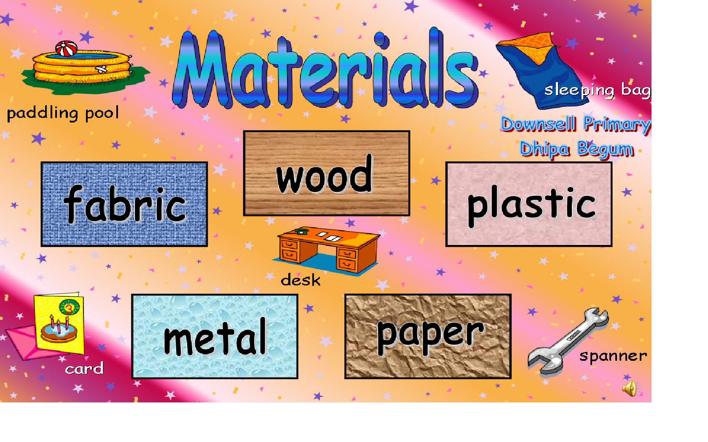 | We will continue to learn about the difference between an object and the material it is made from. We will identify the properties of materials. The children will look at a range of different materials such as wood, plastic, metal and glass and their properties. | Talk to the children about objects around the house and how they look and feel
Art   | Before we start art, we will be finishing off our D&T by making puppets.  In art we will be exploring simple watercolour. We will see how to use surprise and accident to create art. We will then develop our painting by reflecting upon what we see. | Talk to the children about different wild life and plants they can see. What colours are they? Can you see different shades of the same colour?
R.E.  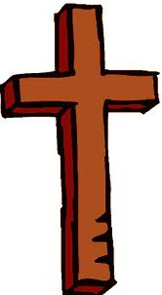 | What does it mean to be part of a faith community?  We will explore the ways in which people in different religions show their belonging to the community and celebrate special occasions. | Talk about different religions at home.
History  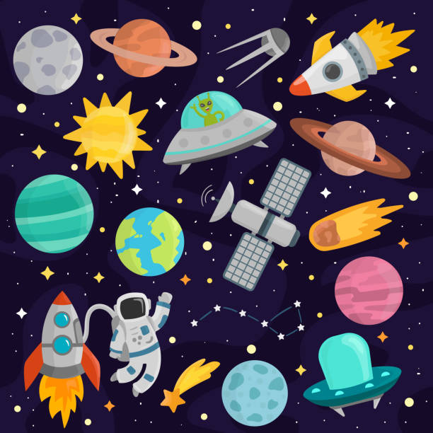 | Who has been to space?  We will learn about Neil Armstrong and the first moon landing, thinking particularly about why he was brave enough to be the first person to walk on the moon. We will also learn about Helen Sharman, the first British person to go into Space and compare her experience with Neil Armstrong. | Use this website to watch videos and play space games. https://www.nasa.gov/stem/forstudents/k-4/index.html
P.E.   | We will develop our target skills and object manipulation over this half term. We will be using balls, nets and bats to improve our accuracy and precision skills. | Practise the skills we have learned in school together at home.
SPANISH   | This half term we will be learning the numbers from 1-10. We will also be learning the names of members of our families. | Reinforce Spanish language at home.
COMPUTING   | This half term we will be learning coding. We will use Purple Mash to learn how to give and follow instructions. We will create a program using code blocks. | Use Purple Mash to play the coding games we have been using in school.
MUSIC   | Learning how to identify high and low notes and to compose a simple tune to represent a superhero. | Listen to and enjoy different pieces of music. Move in different ways to the music.
PSHE  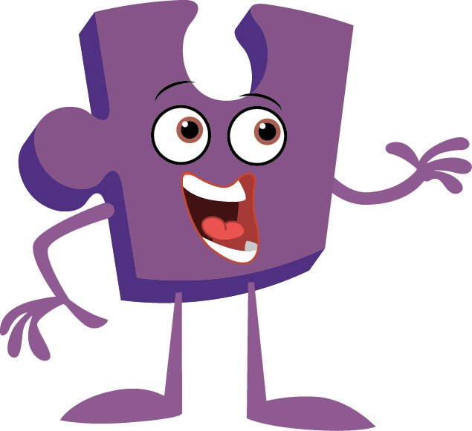 | Relationships  During our PSHE lessons we will focus on the skills needed to build and maintain healthy friendships and relationships. | . Talk to your child about their lessons and what qualities are needed to be a good friend.

Additional Information:
- Read with your child daily. The reading books provided by school will support you in this. Please fill in the reading journal each time you hear your child read (whether it’s their school reading book or another book from home) and ensure that your child’s reading book and reading journal are brought in every Friday.
- Use Spelling Shed to practise the different phonics sounds we have been learning each week.
- Practise on Mathletics every week.
- P.E. is on Tuesdays and Wednesday. Please make sure that your child comes to school in their outdoor P.E. kit on these days ie black shorts / joggers, plain white t-shirt, school jumper and trainers.
- We would welcome help from parents/ grandparents to hear readers in the class. Please see Mr Collingwood if you can help.

