ST MARY’S C E PRIMARY SCHOOL
What are we learning about this half term?

Teacher: Mr Collingwood Year Group: Year 1 Term: Autumn 2

SUBJECT | What we will be learning this half term. | How you can support your child at home.
ENGLISH   | This half term we will be focusing on reading; sharing, and enjoying a variety of books, including  A bear called Paddington – Michael Bond  The Jolly Postman – Allan Ahlberg  We will focus on upper and lower case letter formation finger spaces and constructing simple short sentences.  We will be working through the Set 1/2/3 Phonic sounds further developing our phonic knowledge and applying it in reading and writing words. We will be practising our tricky words and developing our letter formation in handwriting. | Daily reading, asking your children questions about what they have read.  Regular phonics practise, reminding the children to use their phonics in their reading and writing.  Promote independence when writing, encouraging the children to check their work carefully.  www.phonicsplay.com  Practising the tricky words and completing the recap sheets being sent home on a Tuesday.
MATHS   | This half term we will be focusing on:  Pattern in counting to 100  Comparing quantities using part-part whole models  Composition of numbers 0- 5  We will incorporate a range of challenges each week. The children will be given open ended questions to consolidate and embed their understanding of each subject area. | Counting games.  Reading and writing numbers.  Number formation.  Finding one more or one less than a number using objects.  Please see the links on the school website for more help and ideas.  Homework will be sent home on a Tuesday.
R.E.   | In R.E. we will be thinking about why Christmas matters to Christians. We will read the nativity and think about who gave gifts and why to Jesus to help us deeper understand the message of Christmas.  We will look at the incarnation and why the birth of Jesus is so important. | Talk about gift giving and the story of the nativity. Can the children identify the different visitors? Do the children know why the birth was so special?
Computing   | We will be using software tools to group and sort recognisable objects. Children will develop their understanding of how this relates to organising and interpreting data. Children will have the opportunity to collect simple data and present it in a pictogram.  We will continue to reiterate the importance of online safety. | Continue to practice logging in to Purple Mash with your child at home.  Talk to the children about how to keep safe online and how to use any devices at home in a secure manner.
Topic  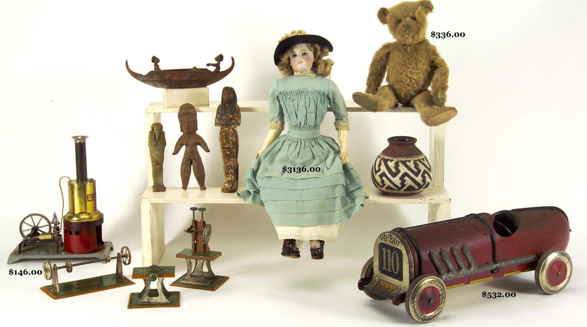 | Our Topic for this half term will continue to look at changes within living memory, specifically toys. | Talk to your children about what life was like when you were their age. What is different? What is the same?
Science  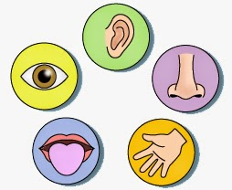 | In science we will start to look at animals including humans. This half term we will mainly be identifying, naming and labelling parts of the human body. We will also be discussing and investigating which parts of the body are associated with which of the senses. | Play games with your children to identify different body parts e.g. heads, shoulders, knees and toes or Simon says.  Discuss the different senses and play guessing games e.g. What can you hear? Taste?
P.E.   | In P.E. we will be looking at net and wall skills, focusing on how to send and receive a ball and learning what a ready position looks like. | Ask the children to show you some skills they have learnt.
Music  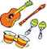 | Using voices, bodies and instruments to listen and respond to different pieces of music, children learn and perform a rhyme and song with a focus on tempo. They focus on the adventures of the Snail and Mouse to  understand how tempo can shape a musical story. | Ask the children to share with you some of the actions they have learnt.
SPANISH   | In Spanish we will be learning the days of the week. | Ask your child to teach you some Spanish words.
PSHE  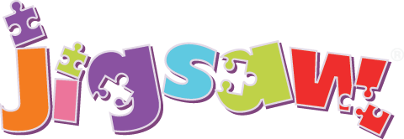 | In PSHE, we will be celebrating differences and similarities as well as focusing on anti-bullying. | Celebrate any differences.

Additional Information:

- Please read with your child daily. (The reading books provided by school will support you in this.) Please fill in the reading journal each time you hear your child read and ensure that your child’s reading book and reading journal are brought in to school every day.
- Homework, in addition to reading, will be given out on a Monday to be completed by the following Monday. This will include tasks on Mathletics and Spelling shed. The children’s log in for this will be in their reading record.
- P.E. is on Tuesdays and Wednesdays. Please make sure that your child wears their P.E kit to school and has hair tied back (as it should be everyday) with no earrings in.

